Known Issues of SurfSafeVPN 1.5 rc10

- Install Issue.
This is a debug/testing version of SurfSafeVPN client. It's unsigned version of our product. On instal you could see next pop-up window:
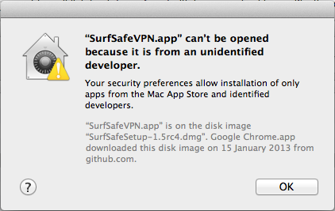
SOLVING:
To solve this isue you should allow run application from anywhere.
Go to: “System Preferences”->”Security & Privacy”
Click on the lock on the bottom of the window to make changes, enter your password and select radio-button near the string “Anywhere”.
Run installer again.
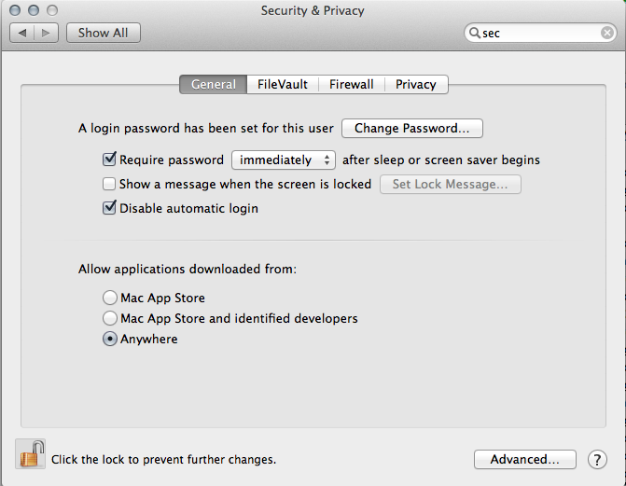
- SurfSafeVPN could conflict with other third-party vpn services.
You could check it in Activity Monitor.

Run: “Applications”->”Utilities”->”Activity Monitor”
-select "All processes" (pic 1)
Check is some process with the name "OPENVPN" is running on your mac.
You shouldn't stop it. However, another running instance of openvpn could lead to some abnormal behaviour of surfsafevpn. So please, report to support about presence of this process in the list before starting surfsafevpn.
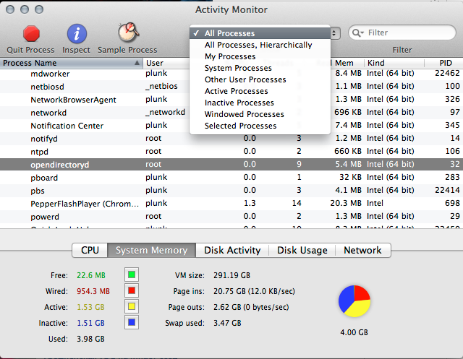
This process should be used by another OpenVPN software like Tunnelblick, Cisco, Viscosity. Try to close this application before establish connection with SurfsafeVPN.

- SurfSafe VPN could conflict with previous installation of SurfSafeVPN
To solve this issue you could perform so-called clean instal:
If you should reproduce any connection failure, could you please follow one more set of my instructions.It's an emulation of a system which have never used SurfSafeVPN client for mac os before.

you need to call 4 commands in terminal:
0. stop SurfSafeVPN client
1. run terminal (applications->terminal)
2. go to home folder with 1st command:
cd ~
3. remove first SurfSafeVPN folder with admin rights with 2nd command:
sudo rm -r Library/Application\ Support/SurfSafeVPN/
4. system could ask you to enter password ("Password:")
5. remove second folder with 3rd command:
sudo rm -r /Library/Application\ Support/SurfSafeVPN/
6. remove app with 4th command:
sudo rm -r /Applications/SurfSafeVPN.app/

Screenshot of normal workflow
